The interface of BLYNK IoT cloud app looks like:

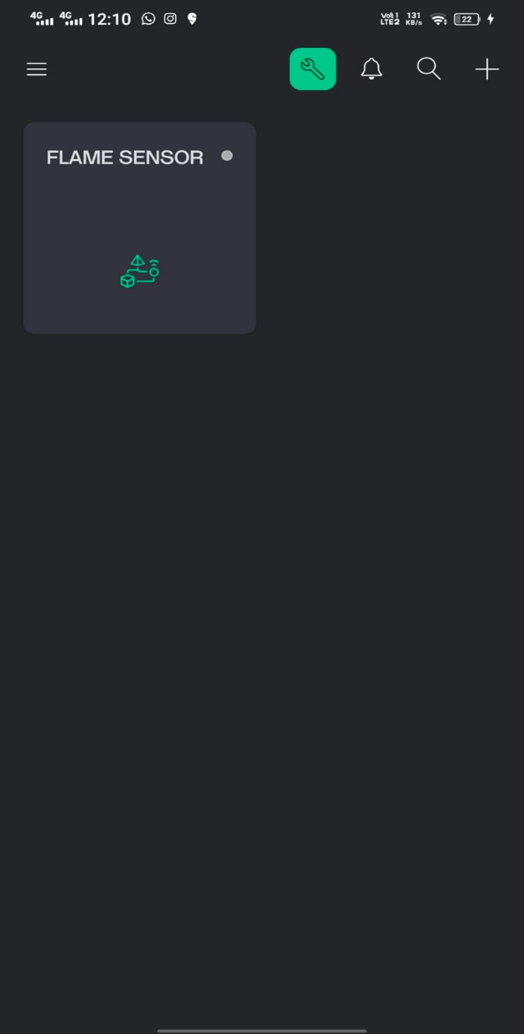On Mobile:

On Desktop:

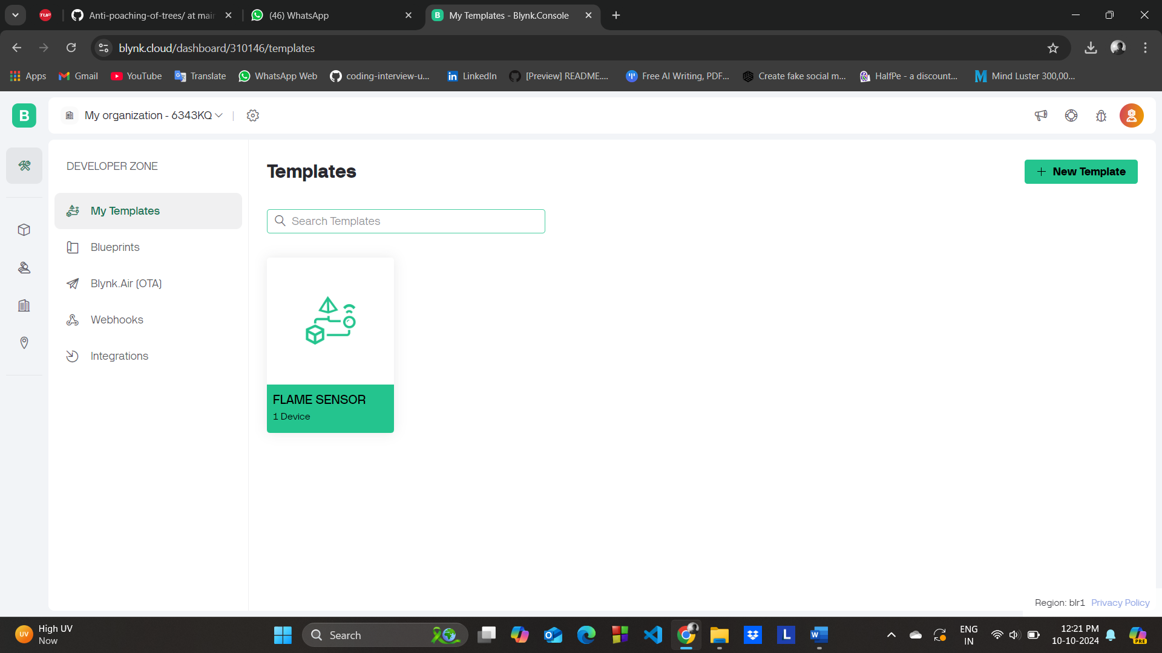

Notification:

|  |  |
| --- | --- |
| On app: | On mail: |
|  |  |